Social Media Toolkit 2022
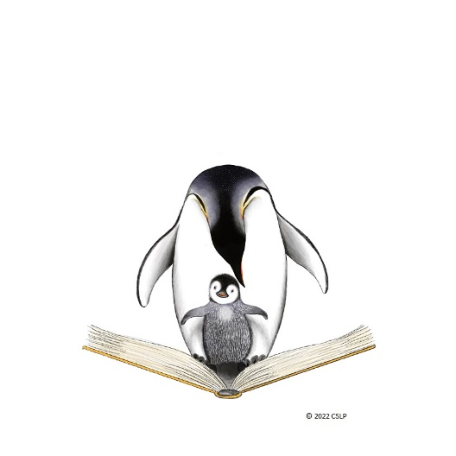
Looking for creative posts and ideas for your library’s social media page? CSLP has got you covered! Check out the images and post captions designed to help your library build excitement, promote, and increase participation in “Oceans of Possibilities” this year. Be sure to check it out for post ideas throughout the year and follow CSLP on Twitter, Facebook, and Pinterest @CSLPreads.
https://bit.ly/CSLP_Toolkit22

