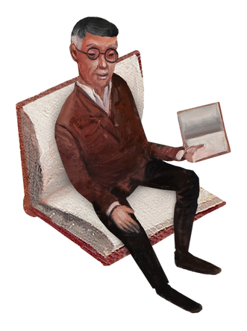APRIL 2023
THU
FRI
SAT


SUN MON TUE WED
 |  |  |  |  |  |  | 1
2 |  | 3 | 4 | 5 | 6 | 7 | 8
9 |  | 10 | 11 | 12 | 13 | 14 | 15
16 |  | 17 | 18 | 19 | 20 | 21 | 22
23 | 30 | 24 | 25 | 26 | 27 | 28 | 29

notes



MAY 2023
THU
FRI
SAT


SUN MON TUE WED
 | 1 | 2 | 3 | 4 | 5 | 6
7 | 8 | 9 | 10 | 11 | 12 | 13
14 | 15 | 16 | 17 | 18 | 19 | 20
21 | 22 | 23 | 24 | 25 | 26 | 27
28 | 29 | 30 | 31

notes

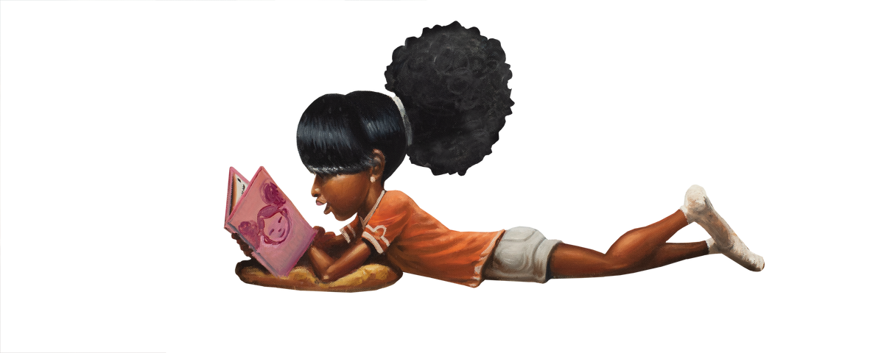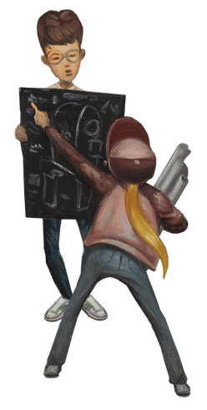JUNE 2023

SUN MON TUE WED THU FRI SAT
 |  |  |  | 1 | 2 | 3
4 | 5 | 6 | 7 | 8 | 9 | 10
11 | 12 | 13 | 14 | 15 | 16 | 17
18 | 19 | 20 | 21 | 22 | 23 | 24
25 | 26 | 27 | 28 | 29 | 30

notes

JULY 2023

SUN MON TUE WED THU FRI SAT
 |  |  |  |  |  |  |  | 1
2 |  | 3 |  | 4 | 5 | 6 | 7 | 8
9 |  | 10 |  | 11 | 12 | 13 | 14 | 15
16 |  | 17 |  | 18 | 19 | 20 | 21 | 22
23 | 30 | 24 | 31 | 25 | 26 | 27 | 28 | 29

notes

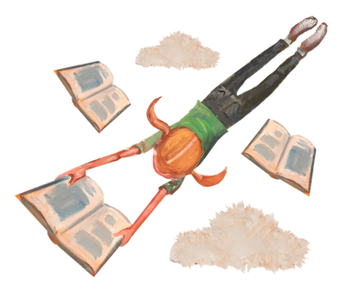AUGST 2023
FRI
SAT

SUN MON TUE WED THU
 |  | 1 | 2 | 3 | 4 | 5
6 | 7 | 8 | 9 | 10 | 11 | 12
13 | 14 | 15 | 16 | 17 | 18 | 19
20 | 21 | 22 | 23 | 24 | 25 | 26
27 | 28 | 29 | 30 | 31

notes

SEPTEMBER 2023

SUN MON TUE WED THU FRI SAT
 |  |  |  |  | 1 | 2
3 | 4 | 5 | 6 | 7 | 8 | 9
10 | 11 | 12 | 13 | 14 | 15 | 16
17 | 18 | 19 | 20 | 21 | 22 | 23
24 | 25 | 26 | 27 | 28 | 29 | 30

notes

