Time Log
Cross out a symbol for each 15-minute block you read.

Each symbol group = 1 hour!
  1. | 2.
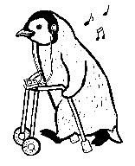  3. |   4.
5. |     6.
7. | 8.
9. | 10.

Name: _______________________________________________________________________________

