CAROL BIRCH, STORYTELLER CSLP APPLICATION April, 2019
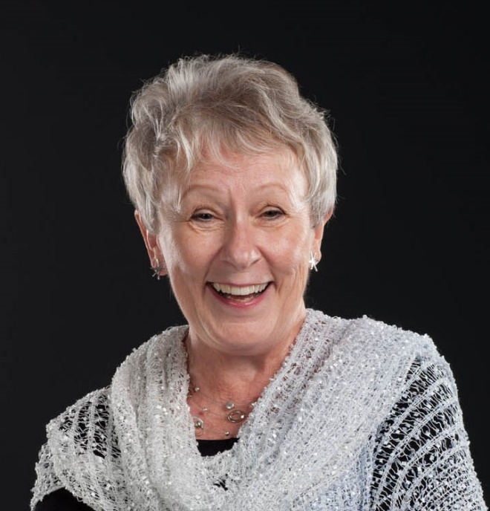
Bio:
With a signature zest, Carol Birch is Connecticut's premier storyteller with a singular place in the National Storytelling Network’s Circle of Excellence, given to those recognized by their peers to be master storytellers. She’s also received the Outstanding Educator & the Millennium Awards for her teaching of storytelling at Southern Connecticut State University. An evaluation by one participant noted: Not many tellers dazzle listeners with the brilliance and humanity of their storytelling and leave them inspired to tell, not intimidated! But that's just what you did. Featured nine times at the National Storytelling Festival in Tennessee, Birch has appeared on more than a hundred festival stages around the world, and lectured at more than fifty universities. She received two grants from NEH; toured Australia, Europe, and Singapore; and led five storytelling tours through Ireland, Scotland and England. Media appearances include ABC's Nightline, the CBS Morning Show and National Public Radio.

Workshop description:
“Let me tell you a story” halts the relentless rush of time, undoing the damage of haste, even as it forges enduring and supple connections. Folk and mythic literature bundle up the past, making them a gift for the future. They also celebrate two things simultaneously: the universal and the specific. The rich broth of story is its universality, while cultural details season the broth adding unique flavors and textures. Our storytelling workshop seeks to strengthen sensitivity to these ingredients. It is intended to develop storytelling techniques to: read/speak more expressively; bring setting into sharper focus; animate characters; and mostly importantly, affirm each person’s voice. The workshop is based on THE WHOLE STORY: USING THE IMAGINATION TO BUILD STORIES.

References:
Ellen Munds, Executive Director at Storytelling Arts of Indiana: 317-828-7855.
Dr. Wendy Nowlan, Professor Emeritus, Southern Connecticut State University: 203-214-6778.

Website: www.carolbirchstoryteller.com
The summary of Information below is from my CV. It details my extensive work in library service, teaching positions in storytelling and literature for children, awards, publications, audio and video recordings.

Storyteller
1971 to present

Adjunct Professor of Storytelling
Southern Connecticut State University 1991 to 2009
Wesleyan University (CT) 1986 - 1999
Loyola-Marymount College (CA) 1977 - 1981
University of Southern California 1977 - 1982
University of California at Los Angeles 1976 - 1980
Long Beach City College (CA) 1977
Youth Services Librarian
Chappaqua Library (NY) 1986 to 2008
Woodbridge Library (NJ) 1972 - 1975
Mercer County Library (NJ) 1971 - 1972

Consultant & Project Director
National Storytelling Association 1990 - 2000
Weston Woods Studios 1983 - 1985
National Endowment for the Humanities 1979 - 1981
Two Grants for "I HEAR TELL" - a proposed television series on storytelling in American cultures.

AWARDS

The Parent-Teacher Association of New York, 2009.
Outstanding contribution as Youth Services Librarian to generations of children in Chappaqua, NY.

The Millennium Award, 2000
Distinguished and outstanding teaching and service in the Storytelling Institute of the Graduate School of Library Science at Southern Connecticut State University.

The Circle of Excellence Award, 1998
For those recognized by peers to be master storytellers, who set the standards for excellence, and who have demonstrated a commitment and dedication to the art over
a significant period of time from the National Storytelling Network.

Outstanding Educator Award, 1994
In recognition of outstanding contributions as Master Teacher/Master Storyteller in the Storytelling Institute of the Graduate School of Library Science at Southern Connecticut State University.

AUTHOR
Books
The Whole Story Handbook: Using Imagery To Complete The Story Experience. August House, 2000. Storytelling World Gold Award; The Anne Izard Storytellers’ Choice Award

Who Says? Essays On Pivotal Issues In Contemporary Storytelling. Co-editor with Melissa Heckler. August House, 1998. Storytelling World Honor Award; The Anne Izard Storytellers’ Choice Award

Essays in books by others;
“Forward” to Engaging Community through Storytelling by Sherry Norfolk and Jane Stenson. Libraries Unlimited, 2017.

“On Setting” in Social Studies in the Storytelling Classroom by Jane Stenson and Sherry Norfolk. Parkhurst Brothers, 2012.

"Storytelling: Practice and Movement" in Teaching Oral Traditions, edited by John Miles Foley. Modern Language Association, 1998.

"Building Bridges with Stories" co-written with Melissa Heckler. The Storytelling Encyclopedia, edited by Marion Sader. Oryx Press, 1997.

Additional Publications: 6 story adaptations; 4 commentaries on stories; 3 Profiles in books; along with 14 periodical articles.

Audio-Recordings
More than a Cup of Kindness. Silver Birch Productions, 2015. Winner Gold Award, Parent’s Press 2016; Storytelling World 2016.

Exchange. Silver Birch Productions, 2015. Winner Storytelling World 2016.

Through the Years, Silver Birch Productions, 2015. A reissue of selected stories from award winning CD’s listed below.

Lou Gehrig: The Story of a Great Man. Silver Birch Productions, 2003. Winner 2003 Storytelling World Honor Award; National Parenting Publications – NAPPA Gold Award.

Sandburg, Out Loud! August House, 2002. Winner 2002 Parent’s Choice Award. Storytelling World Honor Award.

Careful What You Wish For. Frostfire, 1993. Winner 1997, National Parenting Publications Gold Award.

Image-Ination: The Heart (And True Art) Of Storytelling. Frostfire, 1992.

Happily-Ever-After Love Stories...More Or Less. Weston Woods Studios, 1987. **1987, American Library Association one ten NOTABLE RECORDINGS.

Nightmares Rising. Frostfire, 1984. **Winner 1985, The New York Public Library - BEST RECORDING.

Contributor to Audio Anthology.
“Caryn’s Story” on The Listening Tree. Connecticut Storytelling Center, 1995.

"How the Rhinoceros Got His Skin" by Rudyard Kipling on Tales Of Humor And Wit. The National Storytelling Press, 1992.

Director of Recordings Indicates an award winning recording.
Weston Woods Studios
Samuel Babbitt - THE DEVIL'S STORYBOOK by Natalie Babbitt.
Milbre Burch - TOUCH MAGIC stories by Jane Yolen.
Donald Davis - LIVE AND LEARN.
**Donald Davis - JACK TALES: MORE THAN A BEANSTALK.
Heather Forest - TALES OF WOMENFOLK.
Jean Fritz - THE DOUBLE LIFE OF POCAHONTAS
Joe Hayes - FLYING TORTILLAS.
Sonia Landes - A CLOSER LOOK AT PETER RABBIT
Rafe Martin - WILL'S MAMMOTH.
**Michael Parent - TALES AND CHILDHOOD.
**Jackie Torrence - BR'ER RABBIT.
Jane Yolen - THE GIRL WHO CRIED FLOWERS.

The National Storytelling Press
In 1992 and 1993, Carol Birch selected, edited, and arranged approximately seventy-five stories from thousands told at the National Festival for nine outstanding audio-anthologies:
**A STORYTELLING TREASURY: STORIES TOLD AT THE 20th NATIONAL STORYTELLING FESTIVAL - VOLUMES I, II, III, IV, and V.
**BEST LOVED STORIES TOLD AT THE NATIONAL STORYTELLING FESTIVAL - VOLUME I & II.
TALES OF HUMOR AND WIT.
WISE MEN AND SIMPLETONS.

Independent Productions
Milbre Burch - TRANSFORMATIONS. Kind Crone.
**Heather Forest -
ANIMALS COULD TALK. August House.
*WONDERTALES. August House.
Arlo Guthrie - BABY'S STORY BOOK - published by Dutton Children's Books, a division of Penguin Books USA Inc. A Joshua M. Greene Production Stories to Remember for Lightyear Entertainment.
**Mary Hamilton – SISTER’S ALL …AND ONE TROLL. Hidden Spring.
Marianne McShane-EVERYWHERE, EVERYWHERE, CHRISTMAS TONIGHT! GreenIsle.
Producer
After School on Ordinary Days. Hometown Video Awards Winner 2009 in “Cultural Perspectives” category - Carol Birch, Producer. A national award presented by the Alliance for Community Media.

Fees:
$1,400 per day plus airfare, car rental, and lodging if required. Mileage is at IRS rate when applicable. I am willing to offer discounts for multiple sessions in one geographic area, addressed on a case by case basis.

Scheduling information: once a month.

Contact information:
Carol Birch
32-B Heritage Circle
Southbury, CT 06488
home phone: 203-264-3800
cell phone: 203-233-4651
email address: carolbirch@gmail.com
website: www.carolbirchstoryteller.com

