Deborah Eve Freedman
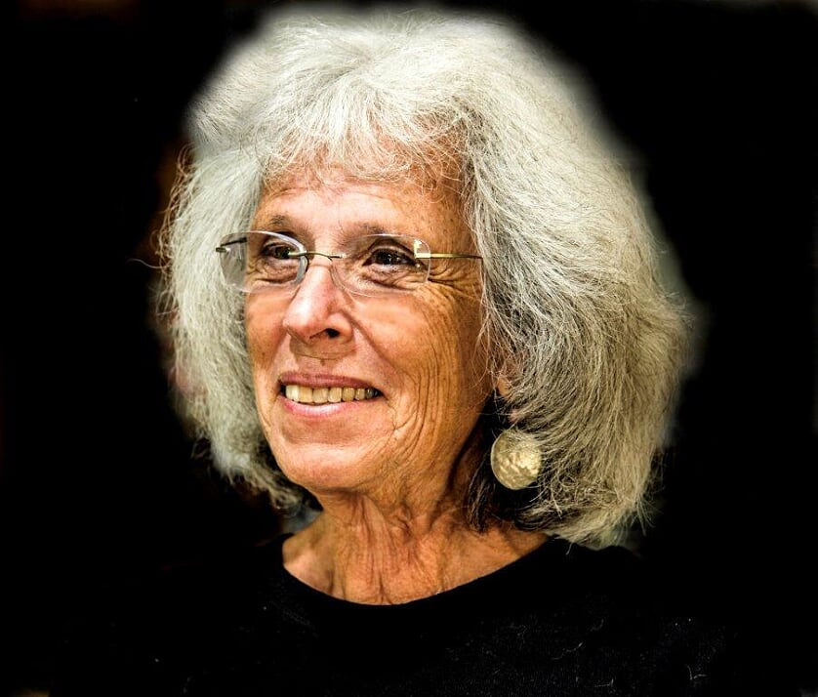
She has a MEd in Adult Education, certificate from Nancy Mellon in therapeutic storytelling, has been creating fairy tales for others since 1996 and been a workshop leader. She has taught workshops at the University of Southern Maine Continuing Ed program, Jung Center in Brunswick, Maine, Sharing the Fire and in her living room. She is the founder of MOOSE (Maine Organization Of Storytelling Enthusiasts). She has authored three books (below) and been invited to share her story-making process at two global conferences at Oxford University resulting in an article in two books (below).

Imagining a Fairy Tale for a Loved One through Heart-Based Learning

One of the languages of the heart is fairy tale. We will awaken this ancient format, with nature as its keystone, by using an intuitive process. In so doing we will bring humanity into harmony with all of creation.
Lying dormant in our bones is the heart-based practice of letting go of control. It is quiet and intuitive and has been very patient.
We will talk about a co-creation process because we need the narrative from the other to create the fairy tale. The value for us is to give it as a gift.
We will create a story for ourselves, then find a partner to orally share a narrative and fairy tale.
List:
Web site: storyspell.com
Publications: self- published trilogy, The Quiet Triumph of the Heart, Moments from Portland, Maine; Names Project AIDS Memorial Quilt Stories from Portland, Maine; The Night Sky is Full of Stars. The Air is Full of Wishes. (a fairy tale).
Articles: Brill Press of the Netherlands: Matters of Telling, The Creating of Fairy Tales 2018.
Brill Press of the Netherlands: Voices of Illness: AIDS Awakens Ancient Stories 2019.
Articles: Two in the Museletter (Northeast Region) on creating fairy tales.
Fees: Four- hour session $550. Eight- hour session $1100 10% discount for multiple sessions
I am willing to travel throughout the country as long as my expenses are paid.
storyspell@hotmail.com
207-245-4740

