Eva Grayzel

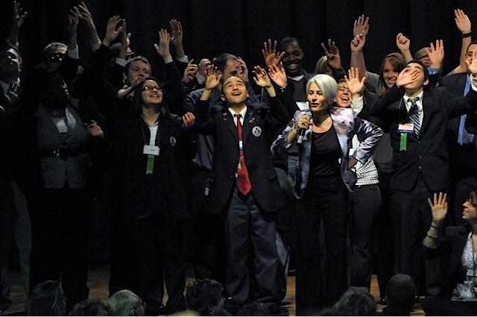

BIO:
I started my career teaching in a religious after-school program. The students didn’t want to be there. The school was looking for someone ‘dramatic’ to engage the students and teach biblical stories. After graduating Barnard College, I pursued a career as an actress and the job did not interfere with auditioning. The seed for my interactive storytelling techniques were birthed in that classroom. I performed stories for all ages, including higher education. At age 33 when I had gigs across the country, I was diagnosed with Stage IV tongue cancer. The irony of it! After regaining my articulation, I began to craft my personal story for the stage. I speak internationally about the patient perspective.

I am the author of two children’s books, Mr. C Plays Hide & Seek and Mr. C the Globetrotter and My Story Legacy, a 12-page guide to document personal stories, a gift more valuable than any material possessions. My signature stories are recorded on the CD, A Story A Day.

Course Description:
I spontaneously invite audience members to role-play characters in stories with meaningful messages. It’s unique! I don’t hesitate to share my secrets with anyone who wants to raise the bar on storytelling.

Depending on the size of the group, attendees could bring a favorite story, (any genre including mythology, fantasy, and fairytales). I would teach how to make that story come to life in the imaginations of the listeners. We would create the illustrations with the people in the group. The interactive nature engages imaginations on a whole new level. Character development is enhanced. The values and messages to be learned are emphasized.

What is the technique? The narrator reads a sentence and puts it in his/her own words while turning an adjective into an action or verb so a participant can act the part. Dialogue is invented to enhance the teaching. Characters development is deepened by making an old story more current and personal to the specific age group. The audience plays a part as a whole, whether it’s the wind, the frogs in the pond, or the sound his belly is making.

Why this technique?
It boosts self-esteem, enhances retention, addresses many learning styles, imparts values and it’s a lot of fun!

Programs: https://www.evagrayzel.com/speaking-programs/education
Testimonials: https://www.evagrayzel.com/testimonials_archive
Publications: https://www.evagrayzel.com/store
Storytelling_1: https://www.youtube.com/watch?v=krtfZ7R3lbE&list=PLXubRsfwT7CUM9ZfsPfpOdXsYH6JZDTSj&index=4&t=0s
Storytelling_2: https://www.youtube.com/watch?v=DUjyHf7mXaM&list=PLXubRsfwT7CUM9ZfsPfpOdXsYH6JZDTSj&index=3&t=0s

Fee: $2500 plus travel (one night hotel and main cabin airfare)
Programs within a 3 hour drive from Jacksonville, FL $1500 plus hotel and .60/mile. Multiple program discount within a 3-hour drive and includes rental car.

Eva Grayzel
Speaker, Storyteller, Author, Patient Advocate
W: 610.258.3763 M: 610.554.9375

www.EvaGrayzel.com
www.SixStepScreening.org

