History: Fantasy or Reality?
Telling the Stories that matter

Description – 6-hour training
Face-to-face and Webinar training. Note: Face-to-face preferred.
Objectives: The participant will:
- Learn the importance of authentic characterization
  - Research
  - Awareness of time period in which character lives/lived
- Gain insight into personal attributes that influence her or him as a storyteller
- Acquire the basic skills of story performance
  - Storytelling stagecraft
    - Triad of audience, performer, and performed personality
    - Use visualization instead of memorization
    - Power of body, voice, pause, and emotion
    - Costume and accouterments of character
- Prepare a statement of purpose for doing character storytelling.

Methodology:
- Lecture and class discussion (50 – 50 balance)
- Practice and coaching

Learning activities:
- Assigned vignettes
- Peer feedback
- Develop list of research sites
- Ethics discussion

Summary Evaluation

Learn more
More information about Principal trainer, Dr. Nielsen, can be found on website www.historical-echoes.com and Institute.historical-echoes.com or by emailing irene@historical-echoes.com.
Website: www.historical-echoes.com
Publications: Institutional of Historical Echoes performer textbooks available at Amazon.
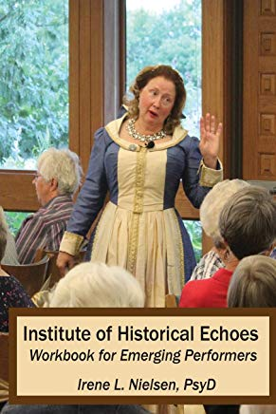
Institute of Historical Echoes: for First-person Performances Workbook (Emerging Performer) (Volume 1)
by Dr. Irene L. Nielsen | Jun 1, 2018

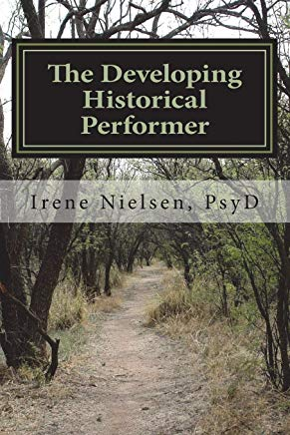
The Developing First-person Historical Performer: ...performing for purpose and social consciousness
by Dr. Irene L. Nielsen | Jul 1, 2018

Contact information
Irene Nielsen, PsyD, MS, CNM, ChFC
irene@historical-echoes.com
425 West Saline, Ste. 6., Lindsborg, KS 67456
785-493-5246 available daily from 1 pm – 9 pm CST

Professional contact biographical introduction
Irene L. Nielsen, Doctor of Psychology, Certified Nurse Midwife, entrepreneur, professor of Psychology, Historical Performer, and Instructor of Institute of Historical Echoes for First-person Performers.
Education includes PsyD in Psychology from University of the Rockies (2014) specializing in health and wellness and MS and CNM from University of Utah (1971).
Teaching face-to-face classes in Psychology (2007 – 2013) and online teaching graduate and undergraduate psychology and supportive media classes (2014 to present).
Instructor at Institute of Historical Echoes for First-person performers, (2018 to present).

Work and entrepreneurial history
2019 - Historical PerformersTM Guild www.historical-performers.org. Under development
2012 – Present Historical Echoes public and contractual performances. Designing Excellence, LLC.
- Majority shareholder
- Veteran, Women-owned
- President
- Artistic director
- Performer with Fellow status

Professional Organizations
- National Storytelling Network (2018 – present)
  - Chair NSN feasibility study for national review accreditation
- Kansas Museum Association
- Historical Performers Guild
- American Psychological Association

Publications and Research
Available at ORCID Publications

Fees for completion and Certification as Historical Performer. Eligible to join Professional PerformerTM Guild.
- $125 per student includes instructor guidance in classes. Textbook to be purchased through Amazon.
- Pre-approved travel is available for classes of ten or more students. For large classes it will be necessary to pay an assistant to give proper student attention.
  - Smaller classes and travel may be negotiable with a minimum tuition fee of $625 equal to the minimum of five students.
  - Maximum class size per instructor is five-students.
- Per diem for car travel at $0.56/mile using Google maps, meal allowance of $30/day for each instructor, and lodging at an approved motel, hotel, or B&B in area for overnight accommodations. Air-travel negotiable by standard economy class with disability transport services. Preferred area around the five-states surrounding Kansas (CO, NE, MO, OK, IA).
- Contracting Host will provide room(s) for lectures, practices, and performances.
- Contracting Host will provide fruit and cheeses for breakout snacks as well as tea and coffee beverages.
- Contracting Host will provide a suitable microphone and basic AV equipment.
- Contracting Host will provide advance and post class publication for class and graduation.

Discounts
No discounts are available for the introductory Performer instruction. Successful students may apply $100 of this fee to complete the full program and Historical Performer Certification at the Institute of Historical Echoes.
A 10% membership discount will be available for graduates’ first-year dues to join the Historical Performers Guild (www.historical-performers.org).

Contact information
Irene Nielsen, PsyD, MS, CNM, ChFC
irene@historical-echoes.com
425 West Saline, Ste. 6., Lindsborg, KS 67456
785-493-5246 available daily from 1 pm – 9 pm CST

Professional contact biographical introduction
Irene L. Nielsen, Doctor of Psychology, Certified Nurse Midwife, entrepreneur, professor of Psychology, Historical Performer, and Instructor of Institute of Historical Echoes for First-person Performers.
Education includes PsyD in Psychology from University of the Rockies (2014) specializing in health and wellness and MS and CNM from University of Utah (1971).
Teaching face-to-face classes in Psychology (2007 – 2013) and online teaching graduate and undergraduate psychology and supportive media classes (2014 to present).
Instructor at Institute of Historical Echoes for First-person performers, (2018 to present).

Work and brief entrepreneurial history
2019 - Historical PerformersTM Guild www.historical- performers.org. Under development
2012 – Present Historical Echoes public and contractual performances. Designing Excellence, LLC.
- Majority shareholder
- Veteran, Women-owned
- President
- Artistic director
- Performer with Fellow status

Professional Organizations
- National Storytelling Network (2018 – present)
  - Chair NSN feasibility study for national review accreditation
- Kansas Museum Association
- Historical PerformersTM Guild
- American Psychological Association
Photos of Associates: Historical Echoes and Professional Performers
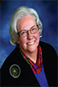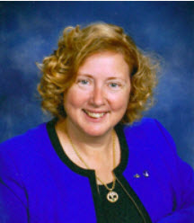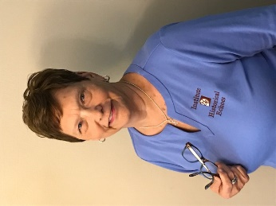
Irene Nielsen, PsyD Bonnie Johnson, MSCI, MSAE Donna Becker, MSN
President CFO Recording Secretary
Fellow Performer Master Performer Developing Performer

