KAREN GOLDEN

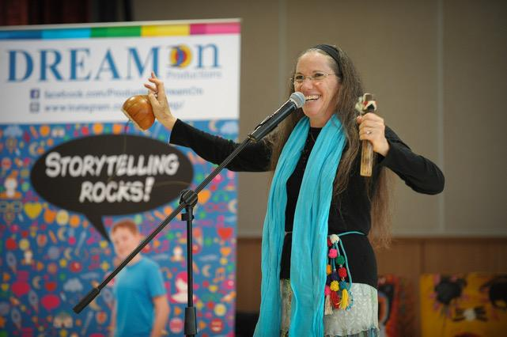
Bio:
Karen Golden is a thirty-year veteran arts educator, performer, musician, published author, recording artist and the founder of Creative Learning Place Inc. a homeschool learning center currently in its 10th year. She has created and developed a storytelling methodology that actively engages listeners through her dynamic use of voice, music, props and audience participation. In “Ignite Your Storytelling Skills”, Karen shares these techniques. She has presented this professional development workshop for the LA County Museum of Art and the La Brea Tar Pits Museum docents training programs, the Skirball Cultural Center teacher workshops, the Los Angeles Public Library, for numerous conferences and for teachers in schools and universities throughout the US and international schools in China, S. Korea, Hong Kong and Peru. Her workshops are lively, hands on and Karen always creates a safe space for experimentation and exploration. Participants leave with the confidence to try something new.
“Ignite Your Storytelling Skills: Imagine Your Story And Pass It On” – A Workshop for Librarians
Outline
1. Storytelling demos – drawing from folk, fairy, myth, and fantasy tales, Karen will demonstrate excerpts. (lecture/ demonstration and approx. ¼ of the total workshop)
2. Bringing an oral story to life, including picture books: A toolbox of hands-on techniques. (handouts & audience participation)
- a. Movement, vocal variety, creating characters
- b. Small props, and scarves
- c. Music: songs, simple percussion and wind instruments
4. Storytelling process (small group discussion)
- Small groups will be given a story to work on using the new techniques.
5. Presentation of stories by small groups (audience involvement)
6. Final questions and comments. (question and answer)
This workshop can be given by webinar.
Participants will practice the new tools and will leave the workshop with at least two new tales to tell.
List your Website:
Karengolden.com
SELECTED PUBLICATIONS
Karen's articles have appeared in:
• Storytelling Magazine
• Communication Research Magazine
• The Jewish Calendar Magazine
• Storytelling World Magazine
• Sharing Ideas Newsmagazine
• Being Jewish, Stories
• The Telling Times
• The Story Bag Newsletter
Karen’s Original Stories Appear In:
• 2018: “Wisdom From Reb Zalman: Embracing The Jewish Spirit ,” edited by Goldie Milgram, Reclaiming Judaism Press, NY
• 2002: “One People, Many Stories: Jewish Stories For Children from Around The World,” audio recording. Produced by Johanna Cooper.
• 2001: “The Jewish Year Celebrating the Holidays,” edited by Barbara Rush, Stewart, Tabori & Chang, New York.
• 2000: “Dancing on the Edge of the World: Jewish Stories Of Faith, Inspiration And Love,” edited by Miryiam Glazer, Lowell House, LA
• 1996: “Nice Jewish Girls: Growing Up In America,” edited by Marlene Adler Marks, Penguin, New York.
• 1995: “Chosen Tales: Stories Told by Jewish Storytellers,” edited by Peninnah Schram, Jason Aronson Inc.: Northvale, NJ.
• 1995: “Many Voices: True Tales From America’s Past,”edited by Mary Weaver, National Storytelling Press: Jonesborough, TN.
• 1994: “Tales As Tools: The Power Of Story in the Classroom,” edited by Mary Weaver, National Storytelling Press: Jonesborough, TN.

AUDIO RECORDINGS
• 1998: “Tales and Scales: Stories of Jewish Wisdom.”
• 2004: “Pass It On: A Journey Through the Jewish Holidays in Story and Song.”
Video Recordings:
https://www.karengolden.com/for-adults.html
https://www.karengolden.com/for-kids.html

- Fees and scheduling information:
$600 for a four-hour workshop
$350 for a two-hour workshop
within ½ hour drive from my home.
My fees are negotiable!

1. How much are you willing to travel?
I am willing to travel. This depends on the time of year and day of the week. I will charge additional for travel expenses and time.
2. Is there a discount for multiple sessions?
I will discount multiple sessions at the same venue or nearby.
3. Contact information (email, phone, agent contact, etc.)
karen@karengolden.com
323-933-4614 home
323-839-9569 cell

