KAREN SANGALINE PILLSWORTH
The Storyteller Laureate of Kingston, NY
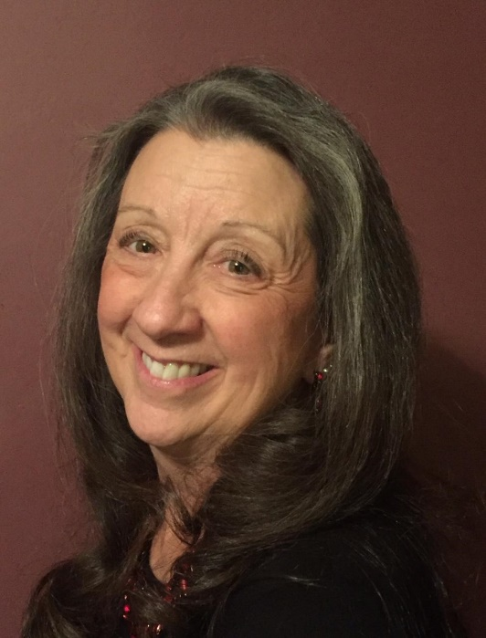

Bio:
Karen Sangaline Pillsworth, the Storyteller Laureate of Kingston, NY has been enchanting audiences from Newfoundland, Canada to Sydney, Australia for over 30 years. Her work as a story practitioner has afforded her the opportunity to work in venues from homeless shelters, to drug and alcohol rehabs, where she works with our most vulnerable populations.
Holding a MS in Early Childhood Education, Karen combines her 33 years of teaching experience with the art of storytelling, to work with teachers, librarians, and other educators, giving workshops and visiting classrooms. A few of Karen’s workshop experiences include:

NY State Librarians
The Montessori Foundation and IMC 22nd International Conference
Sydney International Conference
SC-CC Annual Conference – Newfoundland, Canada
Northlands Annual Storytelling Conference
Sharing the Fire: Northeast Storytelling Conference
NY State Reading Conference
Karen serves on the Board of the Multifaith Storytelling Institute (www.//multifaithstorytellinginstitute.org)

Workshop Description:
As an experienced workshop presenter, AND a retired teacher, I always make sure attendees are actively involved. Additionally, as a storyteller who has presented in libraries for the last 25 years, I also know that the culture of each library is an important aspect of their day to day work with their communities.
Therefore, my workshop includes an introduction (lecture ¼ of time allotted) hands on activities (2/4 of workshop time) and concludes with a review/performance (1/4) so that participants may use the work the next day.
Attendees will learn the basics of storytelling: choosing stories, methods for remembering stories, voice and gesture practice, and confidence building. Librarians already have a bag full of stories at their ready; they just need to get them off the page and into their hearts. Using storytelling games and exercises, participants will learn and practice stories appropriate for the library audiences they wish to engage.

To learn more about my work please visit my web site.
Web-site: www.karenpillsworth.com
Publications: my work is part of The Storytelling Classroom: Applications Across the Curriculum
CD: The Crone and Other Lives I Have Lived
Videos: Available on my web-site and You Tube
Fees: $350 for the first hour, $150 for each additional hour. I am willing to negotiate fees, as I know funding varies from area to area.
Discussion of discounts for multiple sessions happily entertained

Would be happy to share my work throughout the Northeast as long as travel and lodging are included.
Karen Pillsworth
136 Foxhall Ave., Kingston, NY 12401
kpstories@aol.com
914-388-6212

