Loren Niemi: Summer Library Program Workshop Proposal(s)

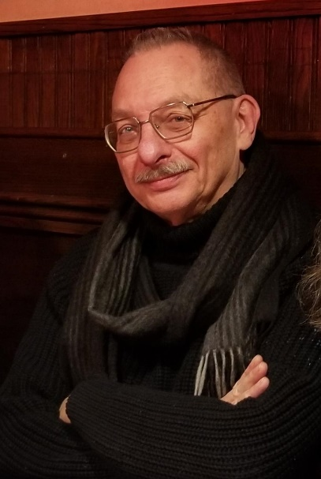

Bio:
Loren Niemi has spent 41 years creating, collecting, coaching and performing innovative, evocative stories about what matters to audiences of all ages in urban and rural settings. He taught Storytelling in the Theater and Communications programs of Metro State University for 26 years and now teaches “Storytelling for Mission and Brand” in the University of St. Thomas’ Executive Leadership Institutes.

He is a published author and poet. His new book, What Haunts Us (from Moonfire Publishing) is a collection of non-traditional ghost stories. Other work includes the award winning The New Book of Plots on the use of narratives in oral and written forms and the critically acclaimed, Inviting the Wolf In: Thinking About Difficult Stories (co-authored with Elizabeth Ellis) on the value and necessity of stories that are hard to hear and harder to tell.

Loren is also the recipient of the 2016 National Storytelling Network’s Lifetime Achievement award.

Publications:
Niemi, Loren What Haunts Us (fiction)
MoonFire Publishing, Minneapolis, MN, 2019

Niemi, Loren Coyote Flies Coach (poetry chapbook)
Sister Black Press, Minneapolis, MN, 2016

Niemi, Loren The New Book of Plots
Parkhurst Borthers Publishers, Little Rock, AR, 2012

Niemi, Loren & Elizabeth Ellis. Inviting the Wolf In: Thinking About Difficult Stories.
August House Publishers, Little Rock, AR: 2001

Contributing Writer (selected non-fiction):
- Storytelling Magazine (1998, 2000, 2002-present)
- Storytelling, Self, Society, Vol. 4, #1 (2008)

- View from the Loft (1992, 1994. 1998)
- MN Alliance for Arts Education Newsletter (1990-’91) (Editor)
- MW Magazine (1989-'91) (columnist)
- Vinyl Arts Magazine (1985-'89) (Performing Arts Reviewer)
- Finnish American Writers (Michael Kaarni Editor) (19830

Contributing Writer (selected Poetry):
- Survival: A Poets Speak Anthology, (2019)
- Coast to Coast: The Route 20 Anthology (2018)
- Walls: A Poets Speak Anthology, (2018)
- Martin Lake Journal, (2018)
- Water: A Poets Speak Anthology, (2017)
- St Paul Almanac, (2010, 2011, 2013)
Website: www.lorenNiemistories.com
Contact info: 651-271-6349
niemistory@gmail.com

Workshop #1 – Putting Flesh on the Bones of Story

Little Red Rising Hood began as a cautionary tale, in what ways is it still? Can we fins inside Brothers Grimm’s Bearskin the story of a veteran suffering from PTSD? This workshop is focused on finding and telling the necessary human and connective meanings of traditional narratives. It engages participants in identifying current issues / themes and finding, then crafting, traditional stories that will draw them out and reinvigorate the tale in the process.

It can be done as a two or three part webinar with assignments for participants to find and craft stories between sessions. It can be done as a four – six hour in person workshop (which I actually prefer) that includes both crafting and performing stories with instructor critique.

Fees: $1500 for webinar when Library provides technical structure.
$1000 for 4-6 hour workshop plus travel / per diem.
Discount: $750 per workshop for multiple workshops.
Travel: Yes.

Workshop #2 - The New Cassandra (politics as metaphor and cautionary story)

From feature film to cartoons, news reporting to satire and cautionary fables, story frames our understanding of politics, culture and the world. Historically artists across all media platforms have documented, critiqued, warned and lamented the politics of culture, patriotism, identity and oppression. Four explorations are the core of the workshop:
The ubiquity of propaganda Witness to times and places
Protest and resistance Metaphors and cautionary tales

This election year workshop can be done as single 4-6 hour experience or through 5 sequential 60-minute sessions in which participants examine, question and articulate via research, conversation and active story making in selected media, their understanding of old tales that remain relevant or new stories in the style of the old, the power of metaphor is in making connections.

Fees: $2000 for 4 webinar sessions when Library provides technical structure.
$1000 for 4-6 hour workshop plus travel / per diem.
$500 per workshop for package of 5 sequential sessions.
Travel: Yes.

