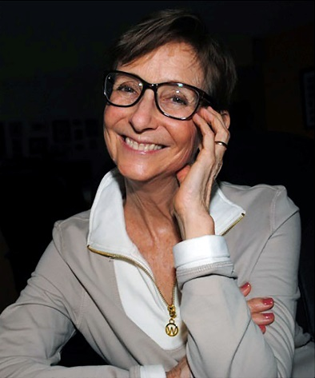
BIO
Mij Byram is a story alchemist, with 25 years of transforming fairytales into treasure for children and adults.
Mij’s dynamic workshops spread the magic of storytelling from Maine to Florida at major libraries, conferences, educational, civic and religious organizations. 10 years of competitive and professional speaking makes her a smooth comfortable speaker, emcee and producer of storytelling events.
Her Bachelor of Arts in Children’s Creative Play inspires STORY&PLAY, the in-demand program at schools and community centers.
Mij believes storytelling gives us the opportunity and responsibility to add more kindness, compassion, honesty, courage and joy to the lives of our listeners. Fairytales allow us to imagine the impossible in order to create the possible.

PUBLICATIONS:
- South Florida Storytelling News, monthly e-news, 2005 – Present
- Articles Contributed to: InSide Story, Florida’s storytelling E-mag and blog 2017, 2019
Northeast Storytelling Virtual Guide for Storytellers, 2018
SN Magazine 2012

RECORDINGS: – See Mijbyram.com

www.MijByram.com
mij@mijbyram.com
561-504-2616
5701 Camino del Sol #305
Boca Raton, FL 33433

WORKSHOP
PARTICIPANTS WILL:
- Gain confidence. Refine technique.
- Prepare audiences for listening.
- Work with props and participation.
- Find, craft, learn and tell a story.
- Expand understanding of storytelling.

WORKSHOP OUTLINE
Why and How  the Magic Works | Intro, Why storytelling? How it’s different. | Lecture | 25 min
Training for Your Transformation | Take hero’s journey to confidence. Refine your technique. Springboard off the page. | Participation  Group practice | 45
Once Upon A Time  Happily Ever After | Openings, closings, songs, poems and more. | Active sharing | 20
Cast the spell.  Transform your Listeners. | Learn field tested techniques to engage and focus audiences. | Get up and move | 30
The Quest, The Craft | Where to find, ways to craft, methods for learning. | Lecture | 30
Make it YOUR Story | Chose and craft a story for telling. | Group work | 30
Magic Kit, Magic Charms | The pro and cons of props and participation | Hands on | 30
Uncover the Treasure | Tell your story. | Individual or group telling | 30
 | Q and A | Group Discussion | 10

¼ Lecture, ¼ Group work, ¼ Hands-on, Active participation ¼ Discussion, Sharing
Times and topics are expanded for 8-hour workshop.

FEES AND SCHEDULING INFORMATION:
- 4 hr. $450 / 8 hr. $800 - within 100-mile radius of Boca Raton
- 4 hr. $450 / 8 hr. $800 - outside 100-mile radius plus standard mileage and per diem rates unless meals and lodging are provided.
- 4 hr. $600 / 8 hr. $900 - outside Florida plus travel and standard per diem rates unless meals and lodging provided.
- Discounts given for multiple sessions in proximity.
- Scheduling flexible.

