Nannette* Watts
Performing Artist, Storyteller, Story Coach, Teaching Artist
10487 N. Aberdeen Ln, Highland, UT 84003 • 801-362-4411 • nannette.watts@gmail.com • nannettewatts.com
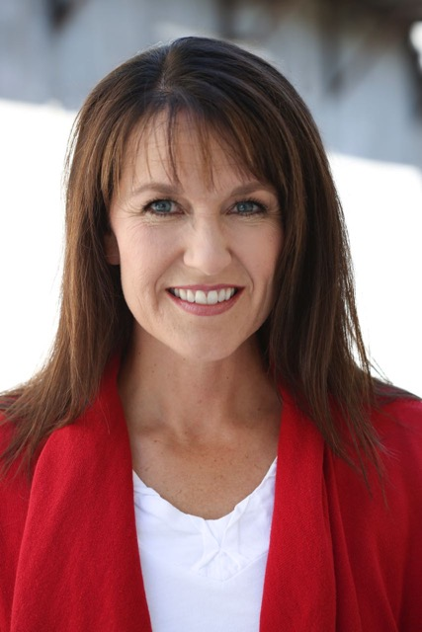

Nannette* Watts Application for the Collaborative Summer Library Program (CSLP) through NSN

Brief Professional Bio
Nannette*;
• holds a B.F.A. in Music Dance Theatre
• continued training through National Storytelling Network Conferences/Summit; Timpanogos Storytelling Conferences; Workshop Intensives with Donald Davis, Syd Lieberman, Carmen Deedy, Rick Walton, Shonaleigh
• is a director of National Youth Storytelling
• serves on Timpanogos Storytelling Committee
• performs at libraries, schools, festivals, camp, and conferences
Recent teaching and performing highlights:
Performance Weber State Storytelling Festival
Performance Orem Public Library
Performance Highland City Library
Professional Development Workshop Weber State Storytelling Festival
Professional Development Workshop Ogden City Libraries
Performances Park City Libraries
Performances Ogden Area Libraries
Residency & Professional Dev. Highland Elementary Storytelling director - 10 yrs
Residencies Murray City Storytelling Festival
Cottonwood High School - debate team
Woodstock Elementary
Riverview Junior High
Workshops & Professional Dev. Timpanogos Storytelling Institute - POPS Program
Performance & Workshop Timpanogos Storytelling Festival and Conference
Performance & Workshop Snake River Storytelling Festival, Idaho
Artistic Director Resonance Story Theatre
Founder, Workshops & Development Story Camp Utah

Workshop Description/Outline

Story ignites and excites all parts of the brain. Hearing a story sends the listener straight to the brain’s learning and processing center. People remember story longer than a list of facts. The Tools of a Storyteller teaches adults, working with youth, how to implement storytelling into their curriculum or programs. In this interactive workshop, participants learn tools to engage imaginations young and seasoned; whether they are telling stories or teaching others to tell.

Handout: Resource list
Discussion 15%; Activity 41%; Lecture/demonstration 43%
Via webinar - yes

I. Create a Safe Place for everyone to participate by setting rules - example

II. Stories are the Key

III. A Strong Tale (discussion)

IV. A Strong Teller (participation activities, games and practice)

V. A Willing Audience

Other Information List:
- Website NannetteWatts.com

- Publications
Watts, Nannette. Youth Tell. Highland, UT: Author, 2004.
Watts, Nannette. “The National Youth Storytelling Showcase.” In Engaging Community Through Storytelling, edited by S. Norfolk and J. Stenson, 123. Santa Barbara, CA: Libraries Unlimited, 2017.
Allen, Laurie, Cassie Ashton, Kristen Clay, and Nannette Watts. Haunted Salt Lake City. Charlston, SC: Haunted America, The History Press, Arcadia Publishing, 2018.

- Video Recordings
The Trickster of Fort Douglas https://www.youtube.com/watch?v=cjnq5xUMwc8
Beard Fertilizer https://youtu.be/FlSg47B85v0
Tree Fall https://www.youtube.com/watch?v=CmgoISyqOw4

- Fees and scheduling information:
+ Willing and able to travel as much as I can
+ Usual fees are $200 per 1/2 to 1 hour event
This is per the going rate in Utah
Going rates per area/state apply, as I do not want to undercut local teaching artists
+ Discounts offered for multiple sessions or residency
+ Willing to work with budgets
+ Travel stipends or per diem may apply

- Contact Information
+ email nannette.Watts@gmail.com
+ phone 801-362-4411
+ website nannettewatts.com
+ snail mail 10487 N. Aberdeen Lane, Highland, UT 84003

