CSLP / NSN Workshop Proposals 2020
from
Randel McGee www.mcgeeproductions.com
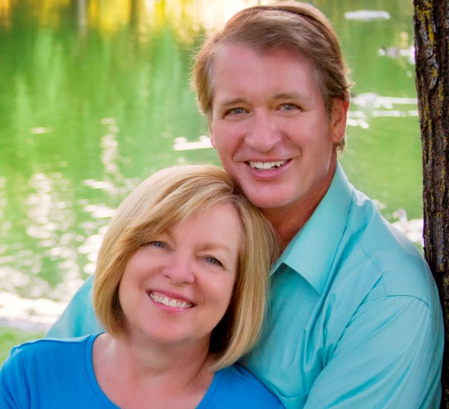
Professional Bio
Randel McGee of McGee Productions in California, USA is an outstanding performer, author, and teaching artist with decades of experience throughout the USA, Europe, and Asia. His programs have been praised for their entertaining nature, but also for their inspirational and educational content. He has years of experience sharing his expertise in using visual and performing arts, such as storytelling, puppetry, ventriloquism, and paper crafts.
Marsha McGee has taught public school and theater courses for Chapman University and CSU-Fresno. She has directed Children's Theater productions and was coach for internationally recognized "Odyssey of the Mind" teams.

Randel and Marsha have extensive backgrounds in working with both children and adults in developing talents in visual and performing arts. They have been college teachers and workshop directors for regional and national library, educational and cultural organizations. Their style is friendly and easily applied in most school and community settings.

Workshop Description:
"Punch it up with Puppets and Props!"
Add Power, Pizzazz, and Punch to your storytelling with simple puppetry techniques, masks, and props. Add a dynamic to your shows that will help propel your stories into an even more fantastic experience. The workshop will demonstrate simple puppets, masks, props and techniques that are easy to use. No previous experience with puppetry is necessary. This workshop is not directed so much to puppet show or play presentations as to supporting a great story with simple visual theatrical elements.
This workshop is mostly a visual demonstration of story sharing techniques, with "Hands On" & "Make and Take" projects included when wanted. It can be shared in live workshops and residencies or via webinars or video chats.

Background Information:
Website: www.mcgeeproductions.com
This lists all of our programs, workshops, residencies, travels, achievements, and useful information!

Fees:
$1000/ day plus Travel and Lodging expenses for 2 (shared lodging)
Multi-day and Group discounts are available.
We are willing to travel anywhere... well, just about!

Contact Information:
Randel McGee
randel@mcgeeproductions.com
Cell phone: USA (559) 582-5307

