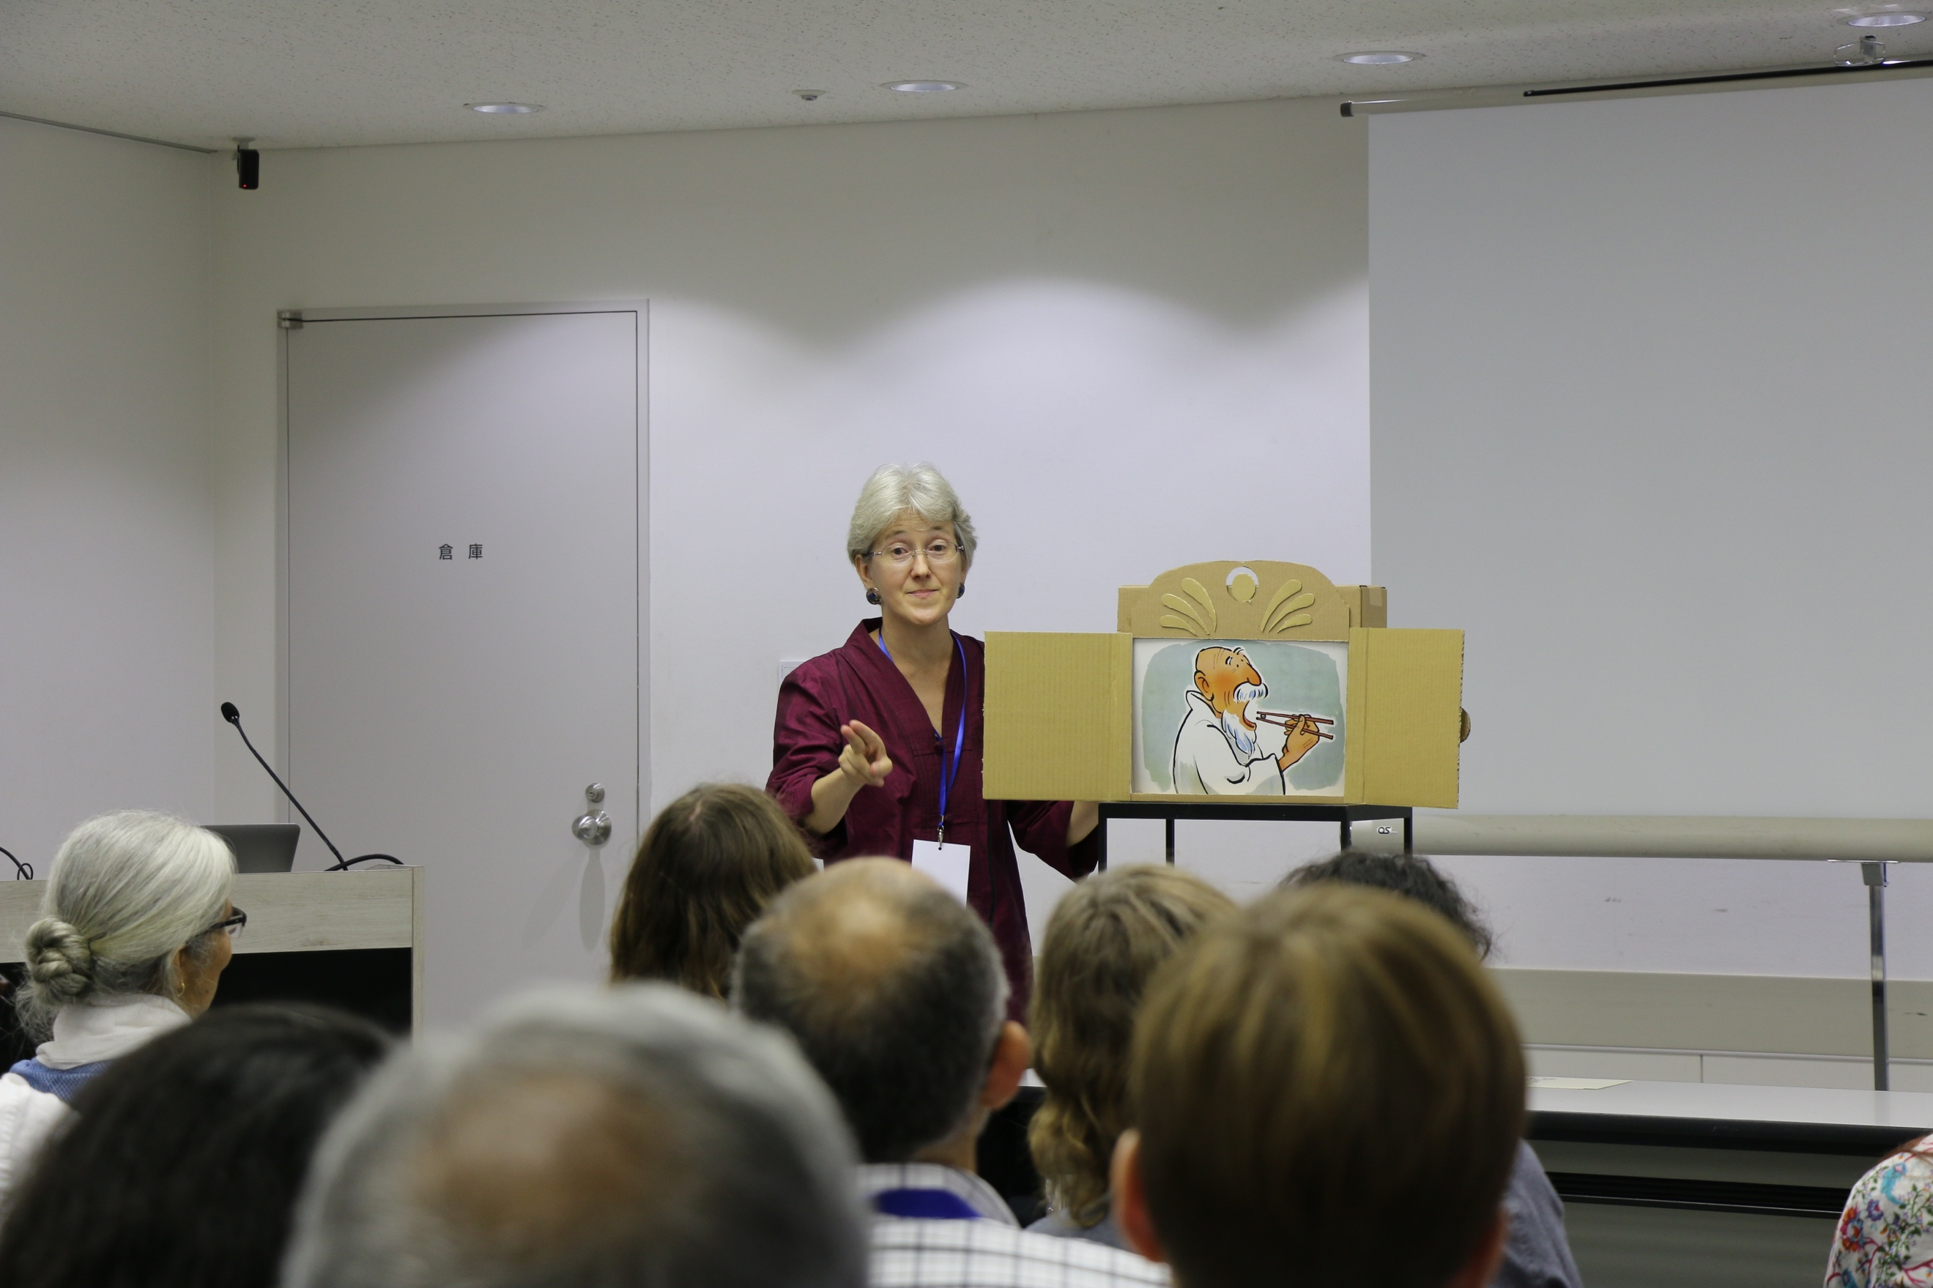

Bio:

Tara M. McGowan is an artist, researcher, and storyteller, who has spent the last two decades studying the history and visual techniques involved in kamishibai (Japanese “paper theater”). She is fluent in Japanese and received her PhD in Language and Literacy at the Graduate School of Education at the University of Pennsylvania. Tara has conducted kamishibai workshops for teachers in the US, Japan, Mexico, and Slovenia. In addition to storytelling programs and workshops in schools, libraries, and museums, Tara also works as a consultant for the Japanese collection of rare children’s books and visual materials in the Cotsen Children’s Library at Princeton University.

Website: www.taramcgowan.com

Books:
The Kamishibai Classroom: Engaging Multiple Literacies through the Art of ‘Paper Theater’ (ABC-CLIO 2010)

Performing Kamishibai: An Emerging New Literacy for a Global Audience (Routledge 2015).

Tara has written numerous articles and curricula about teaching with kamishibai online (see Japan Society of New York website and Kamishibai for Kids spotlight), as well as the afterword for author/illustrator Allen Say’s picture book, The Kamishibai Man (Houghton-Mifflin, 2005).

Outline for 4 hour workshop:

Kamishibai (kah-mee-shee-bye) or “paper drama” is a form of visual animation combined with oral storytelling that began as a street performance art in Japan in the late 1920’s. It is widely recognized today as a precursor of Japanese anime (animation) and manga (graphic novels) and is being adopted around the world for its applications in educational settings. In this workshop, Tara McGowan will begin by demonstrating visual storytelling techniques by performing a series of kamishibai stories. As she performs the stories, she will share techniques she has developed for using kamishibai to teach various aspects of literacy, especially how to build suspense and narrative structure in a fairy tale, myth, or fantasy by drawing upon specific visual techniques in the transitions from one card to the next (50-60 minutes).

Following the presentation, participants will work in groups to put the storytelling techniques they have just learned into practice (120 minutes). They will choose a folktale, myth, or develop their own fantasy stories over 10-16 cards. Participants will first practice performing their stories for one another, and then in the last half hour, will share their stories and respond to them within the larger group.

Cost of workshop: $350 plus $50 for travel of more than 1 hour and cost for materials
(Discount could be considered for multiple sessions)

Because of the hands-on, interactive nature of the workshops, webinars are not ideal. I am willing to consider travel, as long as accommodation and travel expenses are covered.

Materials required:
- 1-2 large pieces of paper (18 x 22 inches) per group
- Pencils, black pens (for outlining), colored pencils, pens, or crayons.
- Poster-board cards cut to the size for the stage

Contact information:

Email:
mcgowantara@gmail.com

Mailing address:
34-F Chicopee Dr.
Princeton, NJ 08540

Telephone:
609-651-7791

