NSN + CSLP Storytelling Workshop Presenter Application

Tracy Chipman Bio: Greetings! I am a Wisconsin based storyteller who stepped onto the path of storytelling under an Oregon hazel tree 24 years ago and hasn’t looked back. At present I travel throughout the Midwest and beyond (Oregon, New Mexico, Vermont) sharing the wonder and power of story and storytelling with all ages and in many ways.
My background is in education and over the years I have offered both storytelling performances and workshops with elementary school students, college students, and adults. Also, there have been multiple professional development workshops in the field of library science and education. More here.

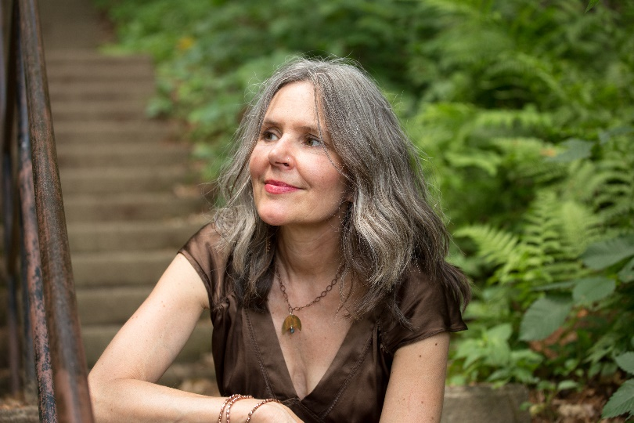

Workshop Description: Once Upon a Library, Where Stories Are Told!
I. Objective – To explore the craft of storytelling and to tell a story!
II. Presentation: Oral-vs-Written, Myth/Lore-vs-Narrative, Listening/Telling, Co-creating, Resources/Appropriation.
III. Storytelling performance
IV. Story mapping
V. Large & small group telling
VI. Attendees storytelling to the group
VII. Closing/Review/Q&A
Teaching methods include both hands on/direct experience with some lecture (25%).
A webinar is possible, (would need tech support) though live is best.
Attendees involvement through active listening, imagining, participation in exercises and discussion, fleshing out their story and telling it. Attendees would expect to learn how to tell a story, a greater understanding of the power/value of oral storytelling, and develop the skills of active listening, imagining, and telling a story with a group.
Fees and scheduling information: Fees depend on the length of workshop and distance traveled. In general, a half day workshop @$550 - $750 plus mileage, full day $1050-$1250 plus mileage, and overnight accommodation if needed.
How much are you willing to travel? Generally, I’d be willing to travel 3-5 times /month in the autumn of 2019 and spring of 2020 (some winter travel is possible depending on location) within the Midwest and open to discussion to more frequent workshops or outside the Midwest. I am willing to offer a discount multiple session.
Contact information: Tracy Chipman | tlchipman@gmail.com | 715.292.1513 | www.listentoatale.com

