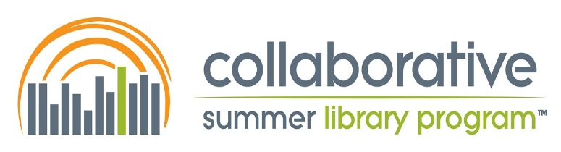

2019-2020 Slate of Nominees for CSLP Positions
Vice President/President-Elect  BriAnne Newton | BriAnne Newton is no stranger to the library profession having spent the last 15 years as a paraprofessional and professional in both the public library and academic setting. During her time in the profession, BriAnne has had the pleasure of serving various libraries and populations throughout South Carolina while watching the wonderful impact that Summer Reading has had on the community. Through her time with CSLP, BriAnne has found a passion that reaches beyond the state lines of her beloved state. It is through her heart to serve, and perhaps her “retired” military brat status, that the work of this organization brings such a joy and passion. BriAnne has served as a CSLP Board Member, Manual Liaison, and Teen Manual Chair throughout the last several years and is excited to see the continued growth of the organization.
Treasurer  Anne Lemay (I)  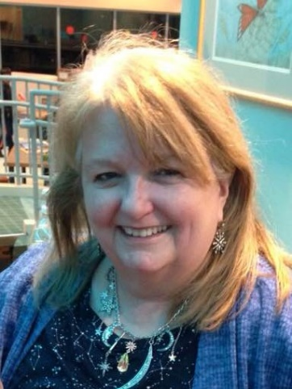 | Anne Lemay has just completed her first term as CSLP Treasurer, and would love to continue for another. She said that being a part of the work to prepare CSLP for launching out on its own with direct sales of its products has been a fascinating process, and she thinks it is important to have continuity as we bridge to the future. Anne finds it relaxing to work with numbers after her crazy days of managing a department staff of 15, creating schedules, and presenting programs.  Anne Lemay has served as a Youth Services librarian since 1986 and as Head of Youth Services at the Franklin Township Public Library in Somerset since 1997. She is the author of Dog Days, Winter Ways: Skits to Promote Reading All Year Long (Highsmith Press, 1994); taught Traditions in Oral Narration, a graduate level course in storytelling, at the Rutgers University School of Communication & Information; and has served as one of the writers for the children’s manual in 2014, 2015, and 2016. She has performed as a storyteller at various libraries and festivals in the NY/NJ tri-state area. She holds a BA in Theater Arts from Douglass College, NJ teacher certification for K-12 (Early Childhood, Elementary, and K-12 Media Specialist), and the MLS from Rutgers School of Communication & Information.
Secretary  Cindy Christin (I)  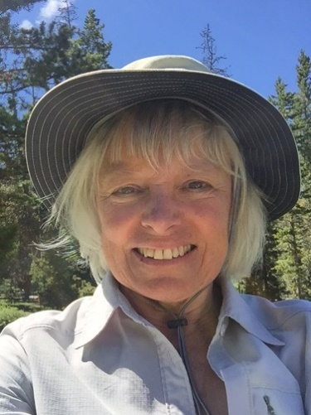 | Cindy Christin is the supervisor of Children’s Services at the Bozeman Public Library, and has been involved with CSLP since Montana became a member in 2000. She has moved on from recording tally marks at past CSLP meetings to serving as Secretary on the Board for the past year. Cindy wanted to be a more active participant in CSLP because she believes strongly in the CSLP mission and enjoys working with CSLP members and the Board. She would love to continue to serve as Secretary for this awesome organization.
Vendor Chair  Deanne Dekle (I)  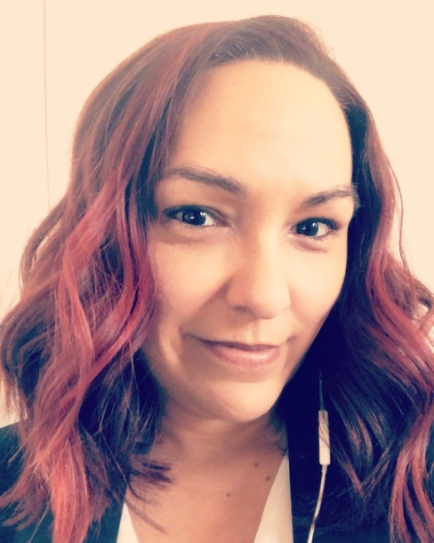 | Deanne Dekle is the current chair of the Vendor Committee. She is also the Artwork Committee chair for the 2020 program year, Imagine Your Story and has served on the Artwork Committees for 2019 and 2021. Prior to becoming Vendor chair, she served on the committee for several years as well as on the Adult Manual committee. Deanne is the Youth Services & Outreach Consultant for the New Mexico State Library. She has served in that position for 4 years. Prior to working for the New Mexico State Library, she spent 7 years as the Children’s Librarian at the Roswell Public Library.
Membership Chair  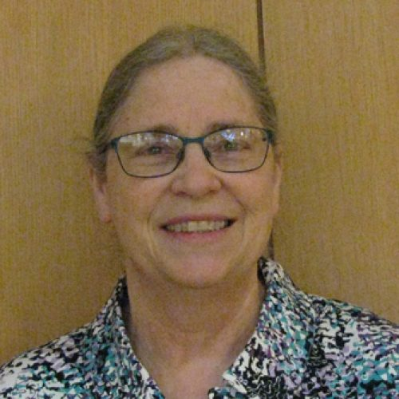  Sally Snyder (I) | Sally Snyder is the Coordinator of Children and Young Adult Library Services at the Nebraska Library Commission, a state agency with the mission of statewide promotion, development, and coordination of library services. She has worked at the Library Commission in various capacities since fall of 1984. She holds a Master’s in Public Administration from the University of Nebraska at Omaha and a Master of Arts in Library Science (MA) from the University of Missouri – Columbia. She served as President of CSLP from September 5, 2007 to May 30, 2009. Her interests outside work include spending time with her husband and their cats, Bart and Tabby, going to the movies, storytelling, (playing “Hay Day” on her iPad – because no animals ever die) and lots of reading.
Membership Chair  Beth Yates  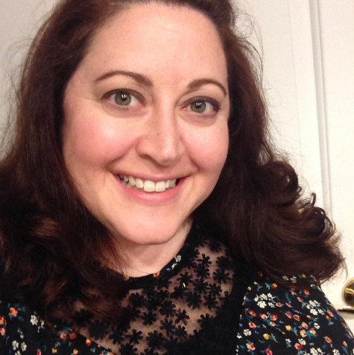 | Beth Yates is the Children’s Services Consultant in the Professional Development Office of the Indiana State Library, where she has provided trainings and support to librarians state-wide for almost four years. Prior to that, Beth was a Children’s Librarian for 12 years at a public library, serving as a Children’s Services Manager for 8 of those years. This is her fourth CSLP Annual Meeting. Beth is a member of both the Membership and Vendor Committees, and has served on the Board as a Member-at-Large since June 2018. She’s excited to be running for Membership Chair, and believes her experiences in both public and state libraries position her well to understand and represent the concerns and best interests of the general membership to the board. Beth has a particular professional interest in early literacy, and she lives in Indianapolis with her husband, two step-sons, and two dogs.
Member-at-Large  Jamie Chipman (I)  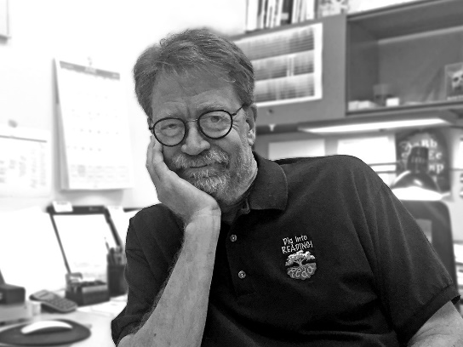 | Jamie Chipman is a graphic designer and involved in many aspects of design since 1978. He holds a BFA from the University of Utah (1980) specializing in television and film design. He worked at television stations in Salt Lake City (KUED-PBS), San Francisco (KQED-PBS, KPIX-CBS) and  Seattle (KING-NBC) and held positions of designer, senior designer and design director. He was art director for Tenth Planet Explorations developing interactive educational software for schools producing math and literacy titles. Currently he is a graphic designer in the marketing department at Salt Lake County Library Services and has  been busy working to promote library services and literacy since 2008. He worked with the Utah State Library to  develop and design a new identity, print and web support  for the Utah Kids Ready to Read campaign.  He was on the board of directors of the Broadcast Designers Association (1992-95) and the Children’s Literature Association of Utah (2015-18). He is honored  to currently serve on CSLP’s board of directors (2017-present).  He has received several silver and bronze awards in print and broadcast design including a NATAS EMMY® for set design (1985, San Francisco/Northern California Chapter). He was also on the software development team that won a SIIA CODiE® Award for Best New Curriculum Software for Middle School (1999).
Member-at-Large  Ashley Biggs | Ashley Biggs has a wide and varied career as a librarian. Most recently, she is the Outreach Librarian for the Maryland State Library for the Blind and Physically Handicapped. Impassioned by the library's mission to serve the print-impaired, she has become an advocate for programs and events and outreach that are accessible to the low vision and blind communities. Ashley believes that with just minimal adaptations, all print-impaired library patrons can enjoy many of the benefits of the public library. She additionally speaks about the need for accessible marketing and websites, thus making it easier for print-impaired individuals to learn about and use library services.  In addition to her desire to bring awareness about low vision and blindness accessibility to public libraries, Ashley has also spoken publicly on the aspect of self-care and mental health awareness in the workplace.

Member-at-Large  Kaelyn Christian  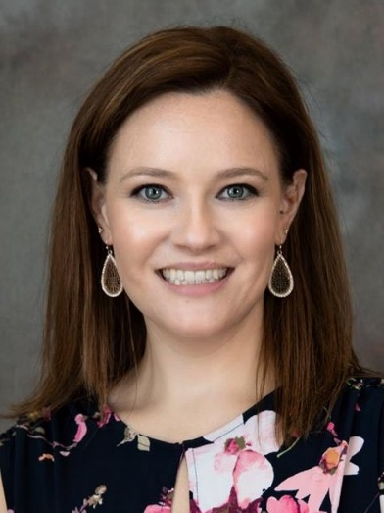 | Kaelyn Christian currently acts as the Head of Youth Services at the Georgetown Township Public Library in Jenison, Michigan. Previously, she’s worked in youth services in Flint, Michigan and Columbus, Georgia. Kaelyn received her MLIS from the University of Denver  in 2013.
Member-at-Large  Deborah Dutcher  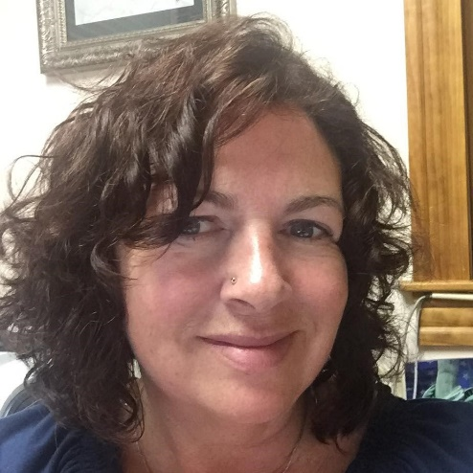 | Deborah Dutcher is the Youth and Adult Services Consultant at the New Hampshire State Library where she provides advisory services to public and school libraries. She coordinates statewide library literacy and family engagement initiatives and develops continuing education workshops for librarians. She serves on state, regional and national committees that foster development of library services to public and school libraries. A current Let's Move in Libraries National Advisory Board Member, she has been Vice President/President/Past-President of the Vermont Library Association and the New England Library Association. She has previously worked in public and school library settings.
Children’s Program Committee Chair  Amanda Antonacci  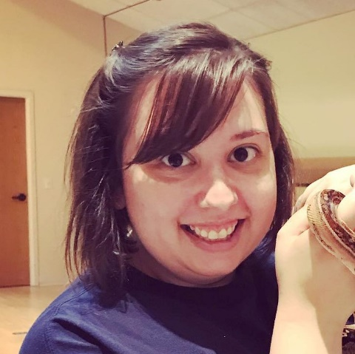 | Amanda Antonacci has been working in libraries since 2012. During her graduate studies, she started working in middle school libraries, and then moved into elementary school libraries, where she worked in both Tennessee and South Carolina. In 2017, she became the Children’s Librarian in the Lancaster County Library System. Since the move to public libraries, she has discovered a love for community partnerships and advocacy for children’s services in a diverse community. Amanda’s primary focus is providing quality services and programming to children of all income and age ranges that dovetail with education objectives to create a stronger community. Summer reading is Amanda’s favorite time of year to engage participants in many different activities that build on education while letting their personalities and imaginations grow.
Children’s Program Committee Chair  Karen Yother  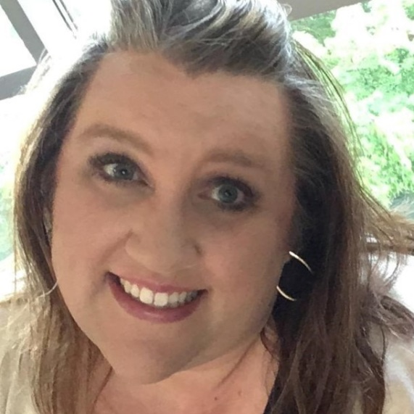 | As the Youth Services Coordinator at the Community Library Network, Karen leads a talented and amazing team of Super Librarians serving children and their families. She has served on various CSLP committees since 2003, including as Vendor Chair and President; most recently on the Leadership and Nomination Committee. Karen received Coeur d’Alene Public Schools “Inspiration Award” on August 5, 2019, the Hayden Chamber of Commerce Youth Award in 2017, was named Librarian of the Year by the Idaho Library Association in 2014, a Pacific Northwest Library Association LEADS emerging leader in 2013 and was selected as one of the Top 30 Leaders Under 40 from the North Idaho Business Journal in 2012. Karen received her Master’s in Library and Information Science with an Emphasis on the Needs of Youth from Drexel University; graduating with honors she was inducted into Beta Phi Mu. She also serves on local and state steering committees, including Jingle Books and the Idaho After school Network, as well as actively participating on the conference planning committees for the Idaho Library Association and the Pacific Northwest Library Association.
Children’s Program Committee Chair  Hannah Stewart  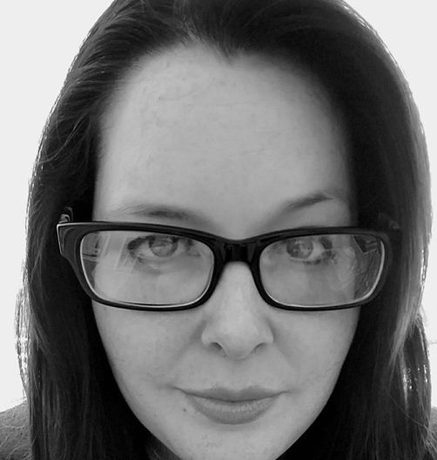 | Hannah Stewart manages the youth services for 8 libraries in the Yuma County Library District and has eight years of experience working in rural and urban libraries. She has a Master of Library and Information Science, and a Master of Arts in English, each with a focus on Young Adult and Children’s Services and Literature. She has trained with NASA to provide STEM-themed programs to children, sat on the advisory committee for the Space Science Institute for the NASA@ My Library initiative, served as project director for several grants including STAR_Net's Discover Space traveling exhibit, and presented at state and national conferences to promote STEM and children's services. She also currently serves as the Southern Regional Representative on the Arizona Library Association Executive Board.
School Outreach Committee Chair  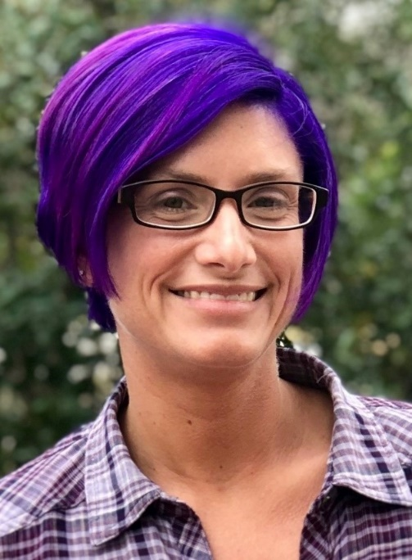  Rebecca Antill | Rebecca Antill is the Youth Services Consultant in the Library Development department of the South Carolina State Library. She received her Master’s in Library and Information Science from Kent State University in Kent, Ohio, and has been working or volunteering in libraries since the age of eleven. Rebecca has worked in public libraries of all sizes in Ohio, North Carolina, and South Carolina. She has worked as the Youth Services Consultant for the SC State Library for 2 ½ years, and in that time has made partnerships between schools and public libraries a priority. Rebecca works on projects such as book award grants for summer camps, universal student library cards, public library involvement in Kindergarten readiness programs and community wide collaborations among informal learning organizations.
School Outreach Committee Chair  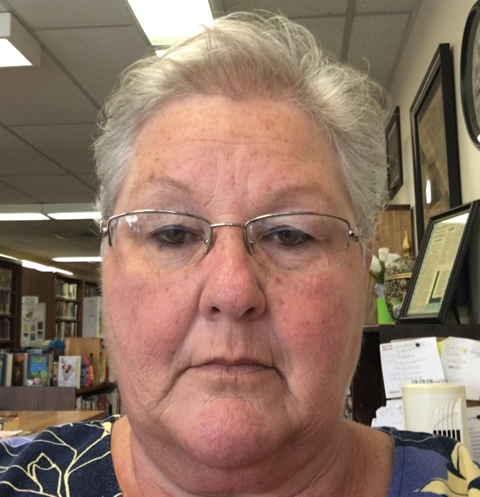  Angela Smith | Angela Smith is a lifelong resident of Livermore, KY. She has a BA in Biology and Chemistry and worked in the McLean County Public School System for 18 years. She began her journey with McLean County Public Library by driving “Betsy Blue,” the bookmobile during summer break. In July, 2014, she was hired full time as Outreach Coordinator for MCPL and holds a Paraprofessional Library certificate from the state of Kentucky. Along with planning activities and events that take place at MCPL with the director, she also drives the bookmobile, host teen/tween activities at the library and also the surrounding cities in the county, plans adult activities, provides Adventure Story Time for Homeschooled children at the library, conducts Story time at 3 preschools, provides STEM/STEAM activities every Monday at one county elementary school, and Tuesday’s and Friday’s at the other two elementary schools on a bi-weekly basis. She also provides STEM/STEAM programming for two high schools classes every week and loves every minute of it. All of the Outreach programs offered to the schools in McLean County take place in the media centers at the schools. MCPL has been #1 in Children’s Programming for the past three years. Angela received the 2016 James Harrison Outstanding Bookmobile/Outreach Services Award at the KY Public Library Association Annual Conference at KPLA.

