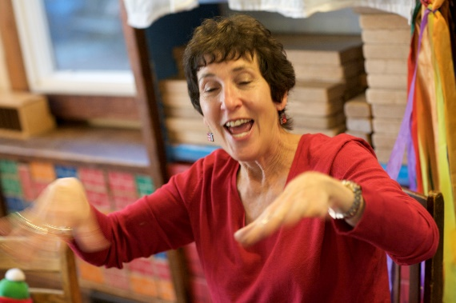
Judy Sima

Judy@JudySima.com
www.JudySima.com
Office: 248-644-3651
Cell: 248-635-5310
7433 Parkdale
West Bloomfield, MI 48322

2020 Summer Library Program Workshop
WORKSHOP DESCRIPTION
Using “Sima’s Six Quick Steps to Storytelling Success,” this highly interactive workshop will give you a template for creating, developing and remembering exciting tellable tales, and leave you with the ability and confidence to tell stories immediately. Using “Bare Bones Fables, Fairy Tales and Folktales” and working in pairs and small groups, you will be guided through choosing a story to tell, reading it aloud, picturing or mapping the story, visualization, practicing and telling the stories you’ve created. You’ll learn how to use your voice, gestures, props, and song to enhance your stories and engage your audience. Learn more about my practical workshops and lively storytelling programs at www.JudySima.com. Call or email for more information: 248-644-3951, Judy@JudySima.com

BIO
Judy Sima is one of Michigan’s favorite storytellers. She has been featured at conferences and festivals, schools and libraries throughout Michigan and across the country. A retired middle school librarian, Judy has been entertaining audiences since 1983. Judy has introduced many young people and adults to the art of storytelling. For seventeen years, Judy coached a middle school student storytelling troupe resulting in her award-winning book, Raising Voices: Creating Youth Storytelling Groups and Troupes. Judy is often called the “Fairy Godmother of Storytelling” as she continually helps and encourages beginning and experienced storytellers develop and improve their craft. She is the recipient of two National Storytelling Network Oracle Awards for “Service and Leadership” as well as “Distinguished National Service.” Judy is also the recipient of The Michigan Association for Media in Education’s “Ruby Brown Award for Individual Excellence” and “Mentorship Award.”

Fees: $600 for a three-hour workshop, $150 each additional hour. Discount for two or more libraries in the same system. Mileage charge: Current IRS rate, first 50 miles free.
For Michigan Libraries, grants covering up to 40% of costs are available through www.michiganhumanities.org/touring-grants
Willing to travel out of state. Additional cost for travel and lodging.

Publications:
“Raising Voices: Creating Youth Storytelling Groups and Troupes.” Libraries Unlimited
Articles in “Storytelling Magazine,” “Media Spectrum,”” Northlands Storytelling Journal,” “Book Links,” and more, available on my website.

