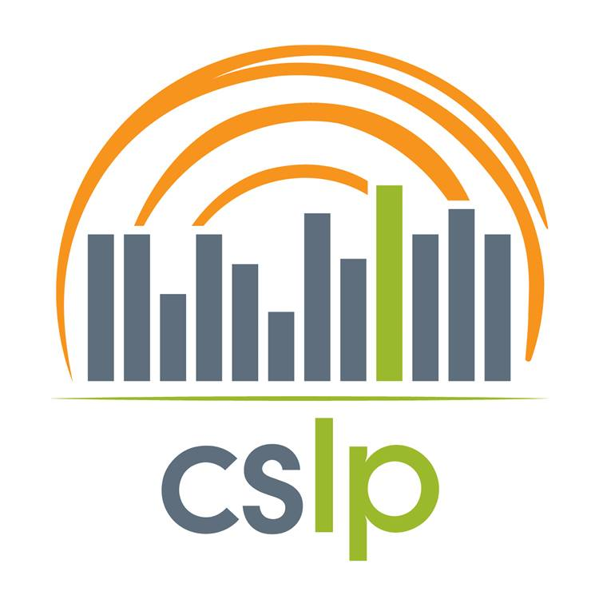

Model Release Form for Publication and Video Purposes for the Teen Video Challenge
Each member of a team that submits a video or, who appears in the video, must sign a release.

This release is between the undersigned and Collaborative Summer Library Program (“CSLP”) and binds both parties’ heirs, successors, representatives and assigns.

Subject of Release. “Material” refers to all video, images, photographs, mixed media, music, text and other forms of copyrighted material that I supply to CSLP.

License. I grant CSLP a perpetual, royalty-free license to use, reproduce, edit, distribute, publish, prepare derivative works, display, and perform the Material in any media form to fulfill CSLP’s mission.

Name and Likeness. I grant CSLP a perpetual, royalty-free license to use my name and likeness, image, voice in the Material as well as my biographical information for advertising, publicity, trade or any other lawful purpose related to fulfilling CSLP’s mission.

No 3rd Party Copyrighted Material. I agree that the Material I submit does not include any copyrighted material belonging to someone else unless it is in the public domain.

No Obligation to Use and No Right to Review. I understand that CSLP is under no obligation to use the Material. I understand that I do not have a right to inspect and approve the finished product or such written or spoken copy used in connection with the finished product.

Consideration. I understand and agree that the sole consideration offered by CSLP is the evaluation of the Material for its potential use, and acknowledge the receipt and adequacy of this consideration.

I understand and agree:
Your Name (printed or typed) __________________________________________________________
Your Address_______________________________________________________________________
Your Email_________________________________________________Your Age ________________
Your Signature____________________________________________________Date______________
Your Telephone No. _________________________________________________________________
Name & City of Your Affiliated Library*____________________________________________________
*If there is no local library, please provide the name of your affiliate library.

Parent’s or Guardian’s Consent is also required, if the person appearing in the Material is under eighteen (18) years of age. I am the parent or legal guardian of the minor named above. I, on behalf of the minor, agree to all provisions of the Release.
Signed ______________________________________________________________Date_________
Name (printed or typed) _____________________________________________________________
Telephone No._______________________ E-mail ________________________________________

