certifies that
Type Your Name Here

has attended the December 2, 2021

Collaborative Summer Library Program’s Summer Symposium
and has successfully completed the following number of education hours:

Type the number of hours you earned here hours
(Note: The keynote and sessions are each worth 1 education hour.)

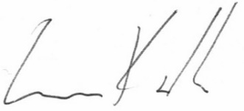
Awarded on December 2, 2021

Luke Kralik / CSLP Executive Director

