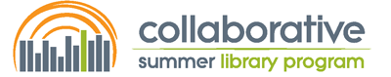

Type Your Name Here

attended the December 8, 2022

Collaborative Summer Library Program’s Summer Symposium
and has successfully completed the following number of education hours:

Type the number of hours you earned here hours
(Note: The keynote and sessions are each worth 1 education hour.)

Awarded on December 8, 2022
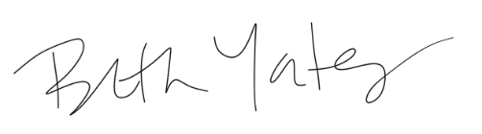
Beth Yates / CSLP Board President

