

ADD NAME
attended the December 4, 2025

Collaborative Summer Library Program Summer Symposium
and has successfully completed the following number of education hours:

4.5 HOURS

Awarded on December 4, 2025
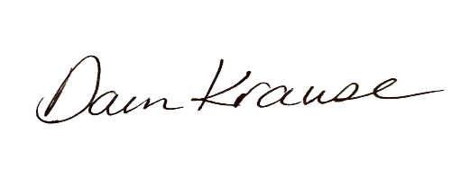
Dawn Krause / CSLP Executive Director

